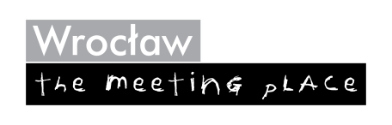  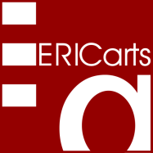 | European Institute of Comparative Cultural Research gGmbH  Ulmenallee 24a, D-50999 Köln (Cologne)  T. +49-2236 5097972  http://www.ericarts.org; Feedback: wiesand@ericarts.org  in collaboration with the City of Wrocław and EUNIC

Project proposal for an interactive database and portal
of transnational cultural awards, bursaries & competitions
(Working title: Transnational Arts Awards)

Executive Summary
This proposal for an Internet portal of transnational awards, bursaries or regular project grants and competition prizes in the field of culture (including the arts, heritage, media, "socio-culture" etc.) reflects priorities of different EU Agendas. In a first step, it will cover all European measures of this type and then reach out to other world regions. Its technology works already successfully in a national model.
The portal will serve, on the one hand, those who seek grants or recognition and, likewise, awarding institutions, cultural policy makers, journalists and researchers all over Europe. Its main goals are:
- Supporting the mobility of artists and other cultural or media professionals;
- The creation of a European co-operation and evaluation platform of funding bodies; and
- A gradual amplification of the scope of awards and similar measures that exist on the national or
regional levels towards a more "European dimension".
The database of the platform will be interactive in order to facilitate permanent updating. It aims to include around 2,000 entries, with all necessary data for easy information and comparison. The budget of the 18 months development and implementation phase will be 185,000 €.
Together with its strategic partners Wrocław and EUNIC, ERICarts welcomes other project partnerships.

A. Background and main objectives
Artists and other culture and media professionals from around the world increasingly appreciate the "European cultural space" as their new work environment – which counterbalances to a certain degree the partly ambiguous "image" of European institutions among the citizens of different countries, as evidenced in recent Eurobarometer surveys. Indeed, cultural awards, scholarships, regular project grants, and specific competitions are important incentives or tools: They open access to a variety of financial measures beyond the local scope that can help to start or develop a career and to encourage mobility. As well, they add up to "symbolic capital" (Pierre Bourdieu) by enabling recipients to gain wider recognition for their work or for projects, they intend to pursue. Since the recent financial crisis will continue to leave its marks on public budgets for culture, professionals are now often looking to support measures in other countries, which either openly invite "foreign" participation or at least do not discourage it.
However, only a minority of the thousands of awards and scholarships offered in Europe and beyond actually meet such expectations: Many of them are not open for applications; others require compliance with certain conditions, including but not limited to using a specific national language. As well, funding bodies and other sponsors often face the unpleasant situation of being overwhelmed with inquiries or applications from grant and information seekers, many of which do not qualify under the terms of such schemes. While the mission of awards given by the EU is normally transparent, the aims of quite a number of other distinctions with a European/transnational scope – which are increasingly devoted to issues such as cultural diversity or intercultural dialogue – appear often obscured by cultural and linguistic traditions.
Reflecting this background and the EU Cultural, External Action and Digital Agendas' goals such as:
- Fostering cultural diversity;
- The promotion of culture as a catalyst for growth and jobs;
- The contribution of culture towards improved international relations of the EU; and
- The creation of 'a true Digital Single Market of Content',
a plan for a new Internet database and portal, provisionally called Transnational Arts Awards, has been developed by ERICarts. Such a portal would be the first of its kind, both content wise and technically. It would create more transparency in this domain while addressing different stakeholders:
- On the one hand, it would definitely enhance the basis of information that is available to funding or recognition seekers by providing them with insights on schemes or grant-giving bodies inviting foreign participation, including on specific conditions that need to be met;
- On the other hand, it will improve the work of funding and award institutions all over Europe by helping them to reduce administrative burdens, to clarify the thematic scope and intentions guiding their measures as well as to compare them with those of other sponsors/promoters. This could lead to complementary programmes and a better exchange among such organisations in a European spirit of cooperation and, in the longer run, to more "open" award conditions.
- In addition, the future directory will serve the planning, reporting or investigation work of cultural policy makers, journalists and researchers. Among these are many who deplore the complexity in the current European landscape of awards, bursaries, regular grants and competitions, which is not alleviated – often rather increased – through the large number of institutional websites and their differing information formats, integrity or styles. In fact, this complexity is currently often "concealing" the good intentions of existing national, regional and local award or grant schemes, diminishing their intercultural potential and hindering EU-wide cooperation efforts.
Therefore, the new portal could provide the chance:
- To highlight and publicly recognise the many existing, public or private, cultural awards, grants etc. with transnational scope, in the spirit of the EU Agenda for Culture (in addition to being listed, this could possibly be done via a new promotional label or through other forms of distinction for support measures that meet certain eligibility criteria);
- To encourage new, or the transformation of old, promotional measures with a similar focus;
- To create a platform for those planning and managing them;
- To carry out research or monitoring exercises, including evaluations of the state of individual cultural funding and promotion opportunities with a "European dimension".
B. Dimensions and features of the future Directory
On the basis of existing manuals and national or topical online-directories, we can estimate the number of regular transnational - or explicitly European - funding or recognition measures of more than local importance in the wider cultural field of the EU member and applicant states at over 1,500. Probably this figure will be even closer to around 2,000, especially if other European countries are included as well.
For this estimate, a European pilot investigation of the ERICarts Network called ABC-INFORM is a useful reference: Carried out in 1999 with the help of partner institutions in Finland, France, Germany, Italy, Sweden and the UK and with additional support from the Alfred Toepfer Foundation F.V.S. (Hamburg), this exercise resulted in ca. 970 transnational awards in Europe. At the time, bilateral measures or those addressing only specific (language-) regions were excluded from the collection, which would add another 500-600 entries. Since the pilot survey could not properly cover some regions, e.g. South-West and Eastern Europe, and since a number of awards, regular grants and scholarships emerged only during the last years, the above figure should be a very conservative guide value. Nevertheless, the experience gained in the pilot study makes the ERICarts Network ideally suited for conducting a more elaborate project such as the guide tool outlined in this proposal.
Other indicators are furnished by the German "Handbuch der Kulturpreise" [Handbook of Cultural Awards], edited by Andreas Joh. Wiesand and financed by the German Government since 1978. Its 5th edition has recently been published as an interactive Web-Portal (www.kulturpreise.de) by ARCult Media GmbH and reports ca. 25% of its 2500 entries as being open to, or designed for, non-German recipients. Shortly after its launch, this portal reported already ca. 40,000 page impressions per month. There are plans to conclude a partnership agreement with ARCult Media in order to assist the construction and the content research for the new Europe-wide portal.
The new directory could take up some features of the German "Handbuch" portal, including:
- A common, interactive database of individual measures (first in English, but designed for user interfaces in different languages to be implemented at a later stage): It is to facilitate continuous updating and the distribution of information to and from different actors and bodies;
- A news and exchange platform: Among its components are reports about important award ceremonies and other events; interviews with recipients and organisers; application deadlines; studies and evaluations; intelligent search functions; featured European and national prizes; sponsors; etc.
In order to give a first impression of the latter services, see here the homepage of www.kulturpreise.de:
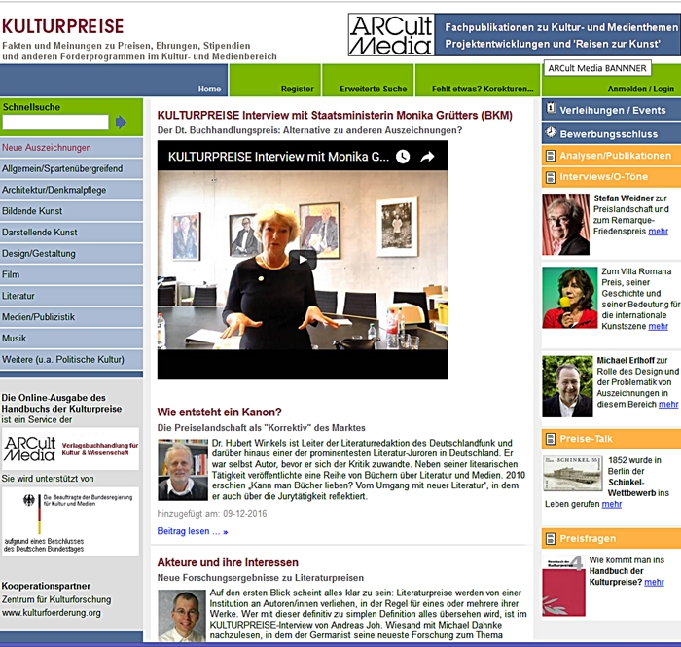

Sectors covered by the portal: General / multidisciplinary cultural achievements; performing and visual arts; literature; heritage/monument preservation; architecture; photography, design and crafts; music; film; media (including journalism and television) and multimedia; community arts and other socio-cultural activities. Still to be discussed is whether film and media awards or competitions should be dealt with
Pending relevant information available from award organisers or other sources, we can envisage the following categories for the individual award entries:

1. Official Name of Award
2. Founding year
3. Donor / Founding organisation
4. Supplementary sponsors
5. Contact address (organiser of the award):
- Contact person
- Mail address
- Telephone, Fax
- E-mail
- Internet address
6. Sector/scope (see above)
7. Type of award (incl. details where relevant):
- Main award (including details and additional classifications where needed);
- Supplementary or promotional award (as above);
- Honorary awards (includes e.g. membership of national academies of arts and letters);
- Regular project grants (as before);
- Other prizes and competitions (as before);
- Scholarships / bursaries (as before).
8. Main goals / intentions of the award or measure (including quotes of statutes, where relevant)
9. Further information on e.g. aims of donor, history, name of award
10. Total monetary value (if relevant – as before)
11. Other benefits/services connected with award:
- Presentation of winner(s) in public forum
- Publication/presentation/exhibition of the work of the winner
- Symposium/lectures
- Travel costs to ceremony are reimbursed
- Certificate, trophy, etc. (+ details)
12. Award cycle (+ date of next award ceremony)
13. Geographical scope (TBD) e.g.
- Bilateral (two countries/regions)
- European Regions (incl. linguistic regions)
- European Union
- All Europe
- International
14. Application
- Required (+application dates; download forms)
- Possible (as before)
- Not possible
If required or possible: conditions
(e.g. proof of professional background; content / language of application; work examples)
15. Typical recipients (typology)
16. Award committee, e.g. jury or donors (+ names and background, where relevant or available)
17. Recipients: Name(s) of winner(s) since 2000

C. Timeframe, partners and cost estimate
Timeframe: Preparations for the Wroclaw Directory could start at the end of 2017 and lead to a test website in late Spring of 2018. The goal is to start the operational phase of the portal by mid-2019.
Similar to previous ERICarts projects with a European scope, the coordination of the directory would be the task of the ERICarts Network, together with the City of Wroclaw and EUNIC and potentially one or two additional partners. Their work includes the planning of the data survey, the updating of existing resources, editorial, administrative and promotional tasks as well as synchronising the efforts of partners.
The programming of the database and its Web implementation could be realised by the Medianale Group, since it has already successfully implemented the "Handbuch der Kulturpreise" portal for ARCult Media GmbH, the European cultural policy platform http://www.culturalpolicies.net and the 1999 pilot study for the ERICarts Institute (which will help to reduce the costs of the new project).
In addition to the City of Wrocław, EUNIC, ARCult Media and Medianale, other Partners are envisaged during the development phase of the portal or later for its maintenance as well as for dissemination tasks:
- European bodies and networks, including those advocating artists' mobility (e.g. On the Move);
- Regional cooperation institutes (e.g. Nordic Culture Point);
- National institutions in charge of cultural relations and the mobility of artists;
- Documentation centres with an international scope (e.g. Boekmanstichting or Institut für Auslandsbeziehungen);
- Foundations with a European scope (e.g. the European Cultural Foundation);
- Individual research partners in different countries, including the ERICarts network (ECURES e.V.).
Selected partners will also be involved in decisions about the design and geographical scope of the portal and some of them may continue to be engaged in a future governance structure.
As an alternative, one could also discuss a platform that could later become part of the EU's own information resources (which should not exclude a future advisory board with representatives of stakeholders and organisers of successful promotional measures with transnational scope in the arts and media).
Expenses during the development phase can be estimated to reach up to 200,000 €, with 185,000 € as a realistic projection. Specialists researching and summarizing facts about national awards will be a major cost factor (details and alternative implementation scenarios still to be discussed with potential partners).
In a medium-term perspective, updates of the directory could be organised as a self-sustaining service (similar to the German model) or as part of the service and information infrastructure of the EU: Due to its interactive database, the updating of entries can be in the hands of award organisers, which reduces maintenance costs. While regular entries should remain free of charge for award organisers, fees for additional features (e.g. photos/films of award ceremonies) or "premium entries" could recover part of the running expenses. Sponsors and a book publication of the directory could be additional sources of income.

